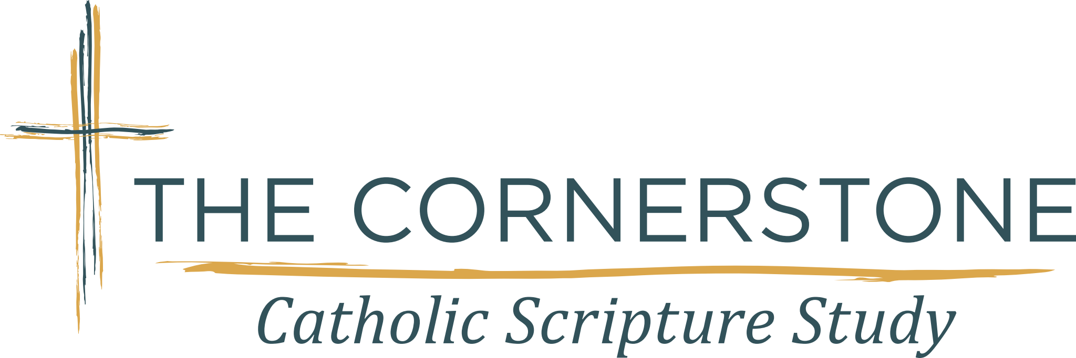

BULLETIN BRIEF (BLURB)
The Book of Acts of the Apostles
The Cornerstone Catholic Scripture Study,
Study. Connect. Transform. These words describe the mission of The Cornerstone Catholic Scripture Study. We invite you to join us for our upcoming study of The Book of ACTS of the Apostles, “Holy Boldness in the Church”. This study is for adults who wish to deepen their faith through an increased knowledge of the inspired Word of God, which can transform your heart and mind. Weekly meetings will be held from September 2025 thru April 2026. For more information about other Branch locations and our upcoming study please visit our website at www.thecornerstonescripturestudy.org

