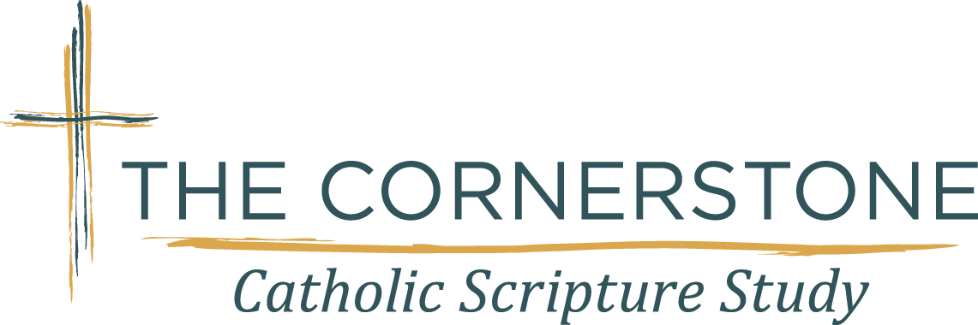

Study. Connect. Transform.
Study
The Bible is the Word of God, spoken in the past
and alive in the present.

Transform
The Cornerstone can lead to
spiritual growth that transforms you little by little, step by step.

Connect
The Cornerstone gives you
a sense of connection with God and those with whom you share the journey.
All you have is 15 minutes? Perfect! 15 minutes is all you need for your daily study.

We use a 4-Part Method for our study:
- Daily Study Questions
- Two Weekly Talks (a short FOCUS and a spiritual REFLECTION)
- Small Group Sharing/Prayer
- Theological Commentary

The Cornerstone Catholic Scripture Study strives to build, strengthen
and deepen a personal and loving relationship with God and
His people through prayer and the study of His Word.

Our 2025-2026 study is The Acts of the Apostles.
The Cornerstone invites men and women to meet with us to study
The Word of God beginning in September. ..
For information on how to join or start a Branch in your parish
contact us thru our website
under connect with us or email us at info@thecornerstonescripturestudy.org

www.thecornerstonescripturestudy.org

